**Jenkins Installation**

**Jenkins Installation Steps**

**(Pre-requisite - Update and Upgrade Ubuntu OS and install open jdk version 17)**

apt update -y && apt upgrade -y && apt install openjdk-17-jdk -y



**(Check Java Version)**

java --version



**(Download Jenkins package from the internet Repo epel)**

curl -fsSL https://pkg.jenkins.io/debian-stable/jenkins.io-2023.key | sudo tee \

/usr/share/keyrings/jenkins-keyring.asc > /dev/null



**(Update the server repo with Jenkins Packages)**

echo deb [signed-by=/usr/share/keyrings/jenkins-keyring.asc] \

https://pkg.jenkins.io/debian-stable binary/ | sudo tee \

/etc/apt/sources.list.d/jenkins.list > /dev/null



**(Update the OS Repo with Jenkins Packages)**

sudo apt update -y

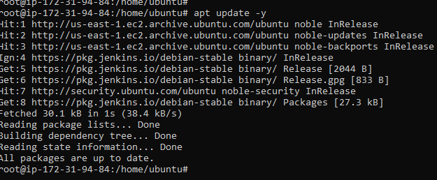

**(Install Jenkins)**

sudo apt install jenkins -y

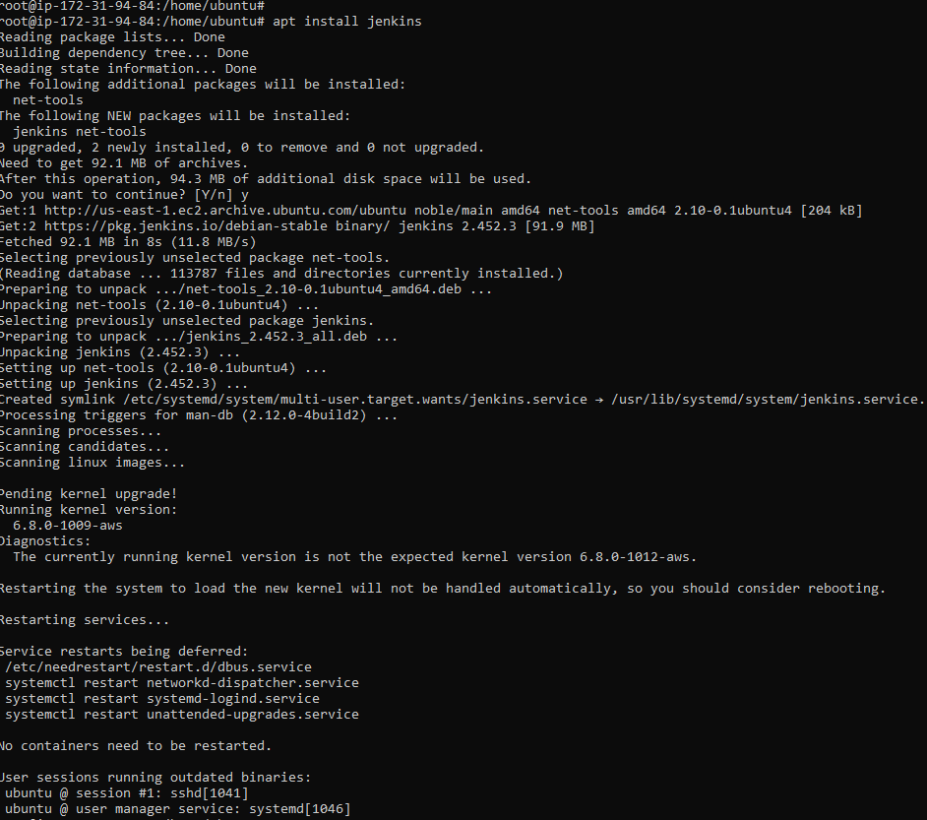

**(Jenkins Service Default location)**

/usr/lib/systemd/system/jenkins.service



**(Start Jenkins Service)**

systemctl start Jenkins



**Post Installation Steps**

Once Jenkins is installed, Open the Webpage now type Public IP of Jenkins: port Number (Default port for Jenkins is 8080) to confirm Jenkins is installed and updated

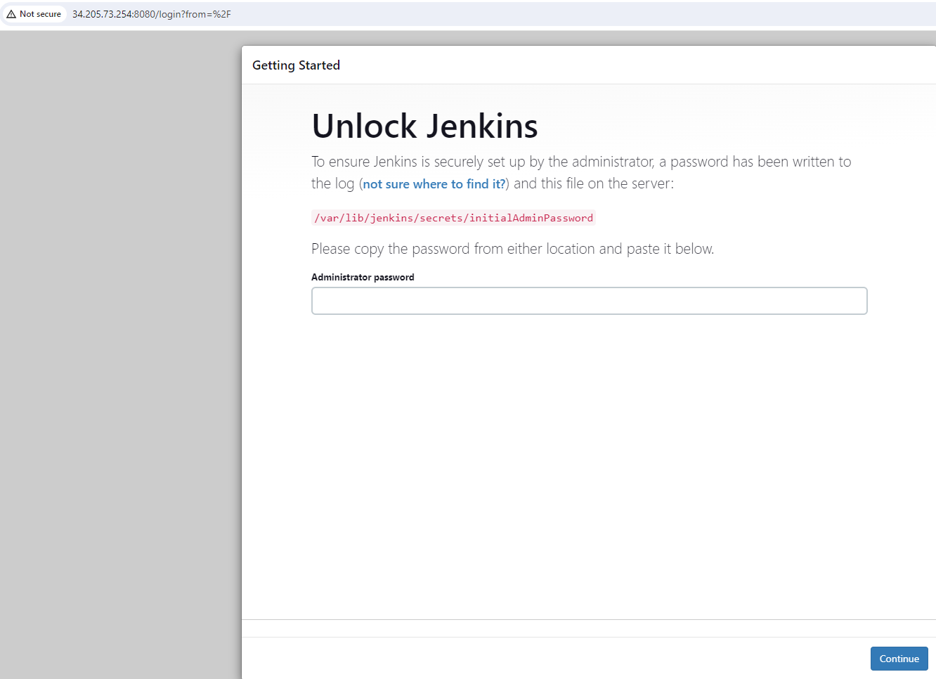

Once installation is done enter the default admin password from the below location on the ubuntu server where Jenkins is installed

**cat /var/lib/jenkins/secrets/initialAdminPassword**



Enter the password on the below screen and click continue



Select Install Suggested Plugins on the below screen

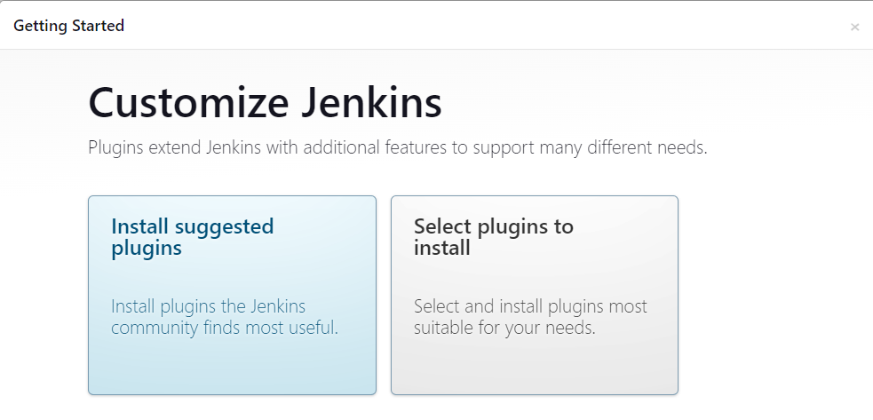

Suggested plugins are installing

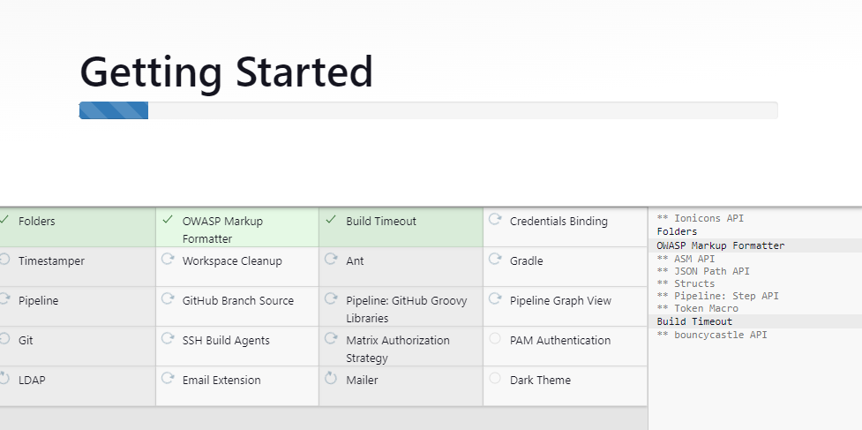

Create first Admin User on below screen and click save and continue

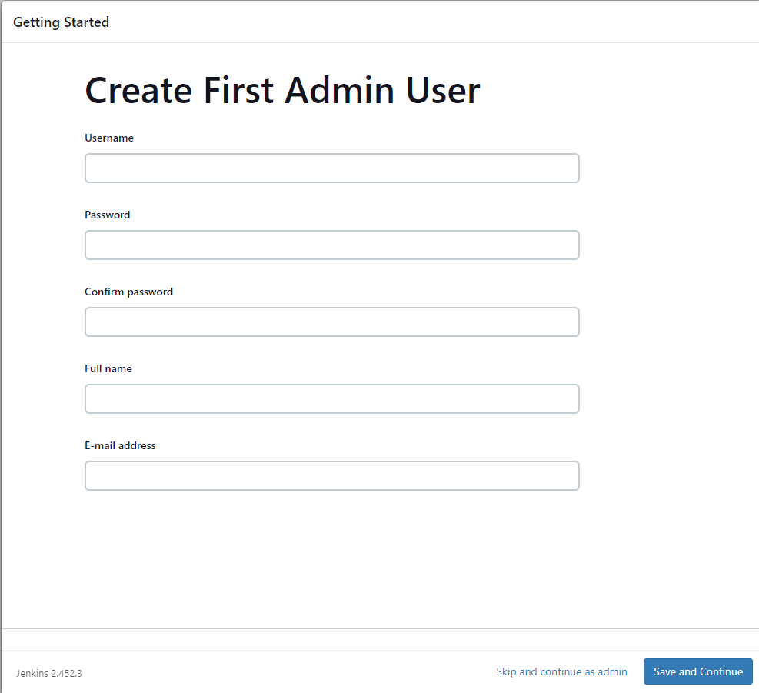

Verify Instance Configuration and click Save and Finish

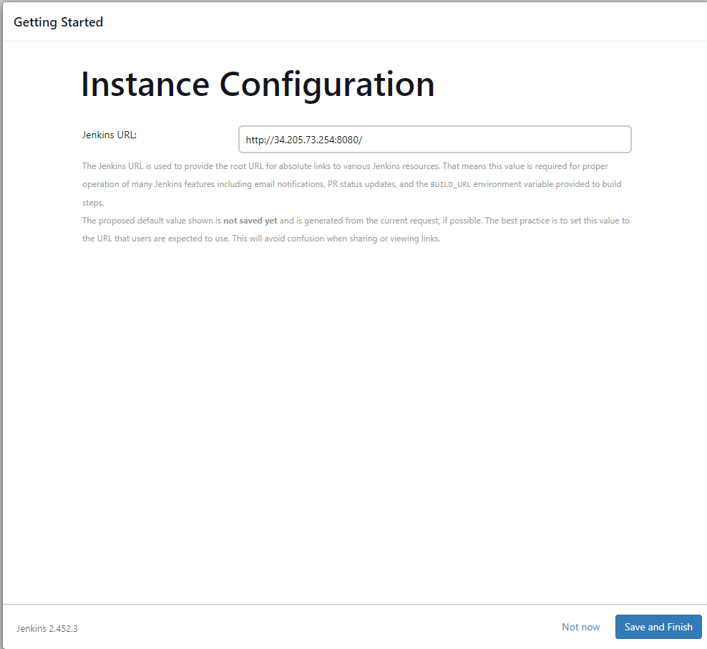

Jenkins Setup is complete. Click Start using Jenkins in the below screen

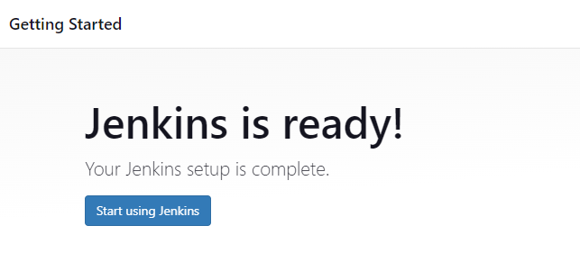

Jenkins dashboard

